Module Name: Login
Test Case ID: SD_TC_004
● Scenario ID: 1a
Scenario: open damo web shop
Test Steps: 1 click to open

Scareenshots:
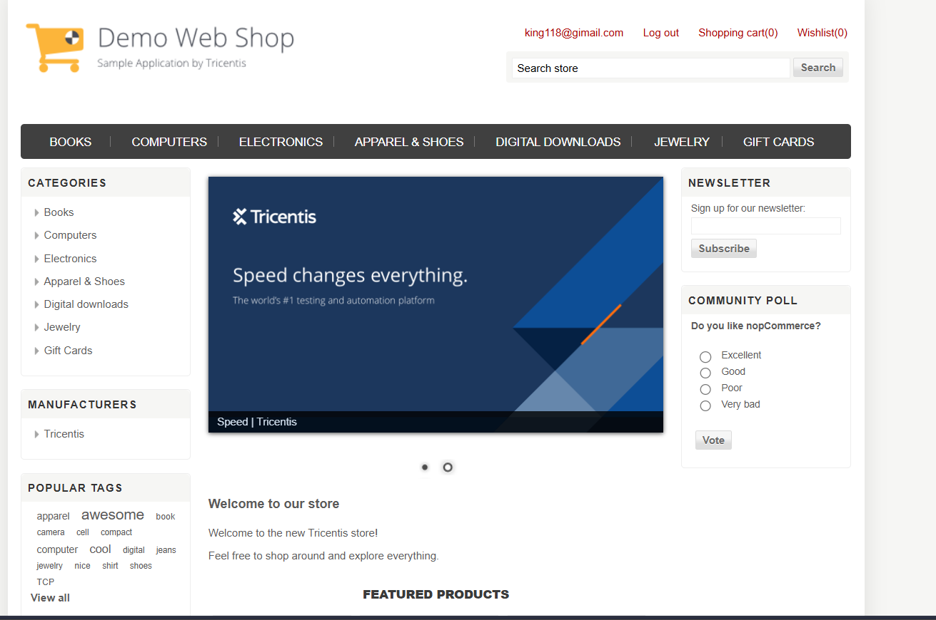
● Scenario ID: 1c
Scenario: enter wrong info
Test Steps:
1 enter wrong password 12345678
2 enter wrong email; kukkusung@gimai.com
Scrensort
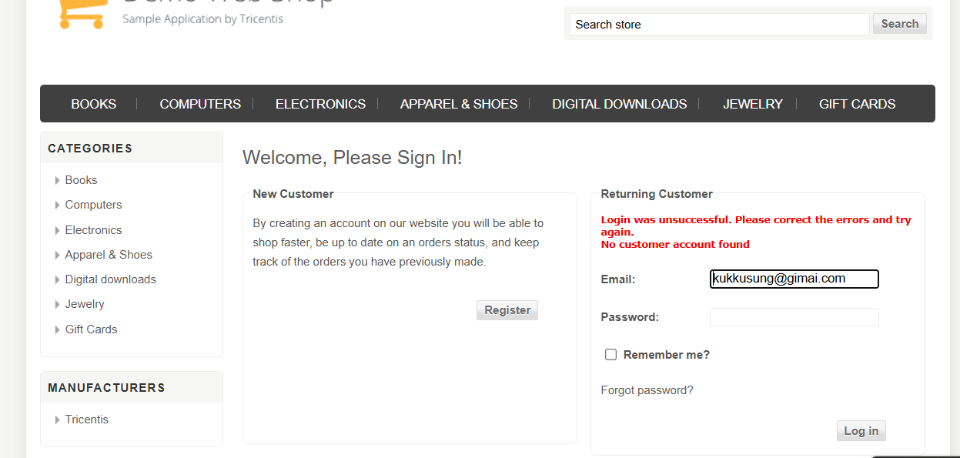
● Scenario ID:
Scenario: add something in to cart
Test Steps: add something in to cart
Screen sort

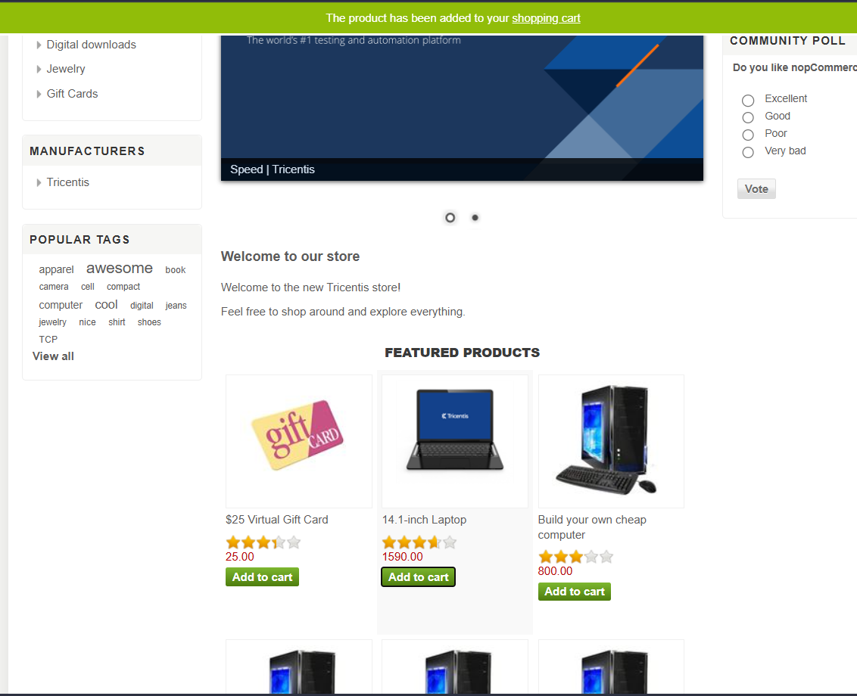
● Scenario ID: 2b
Scenario: edit qty ammount
Test Steps:
:1 click add
2: edit 4 to 100
Screen short

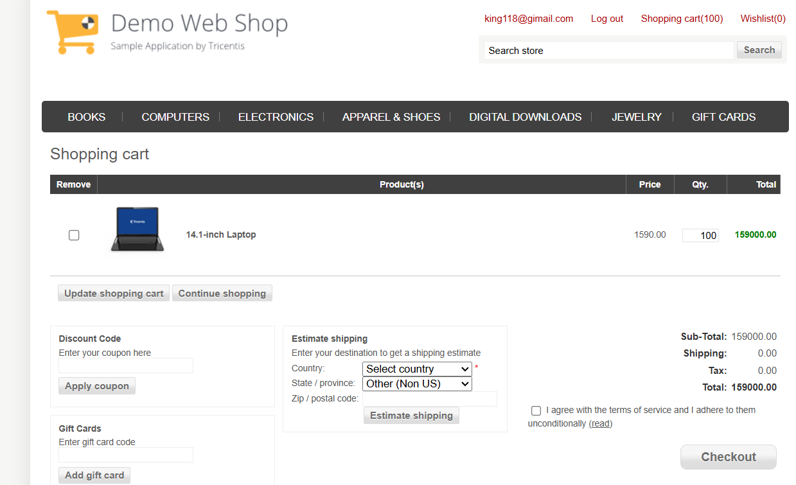

● Scenario ID: 2c
Scenario: edit qty amount (10000)
Test Steps:
:1 click add
2: edit 4 to 10000
Screen short
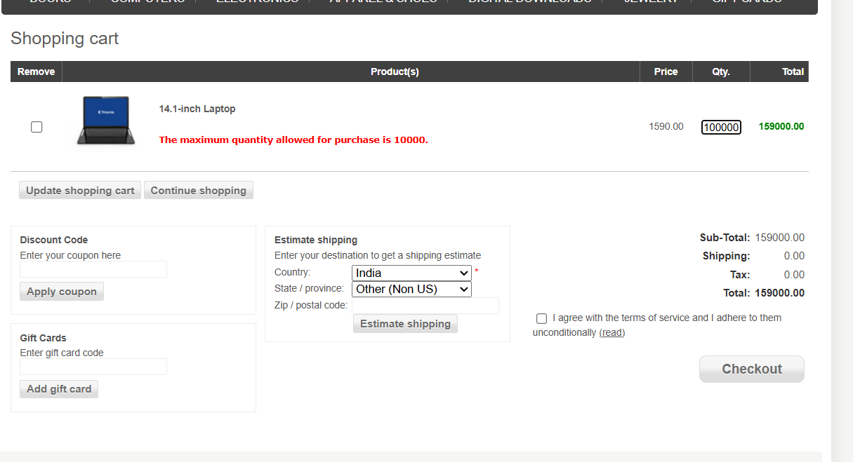
● Scenario ID: 3a
Scenario: logging speed
Test Steps:
:1 tap to logging
Screen short
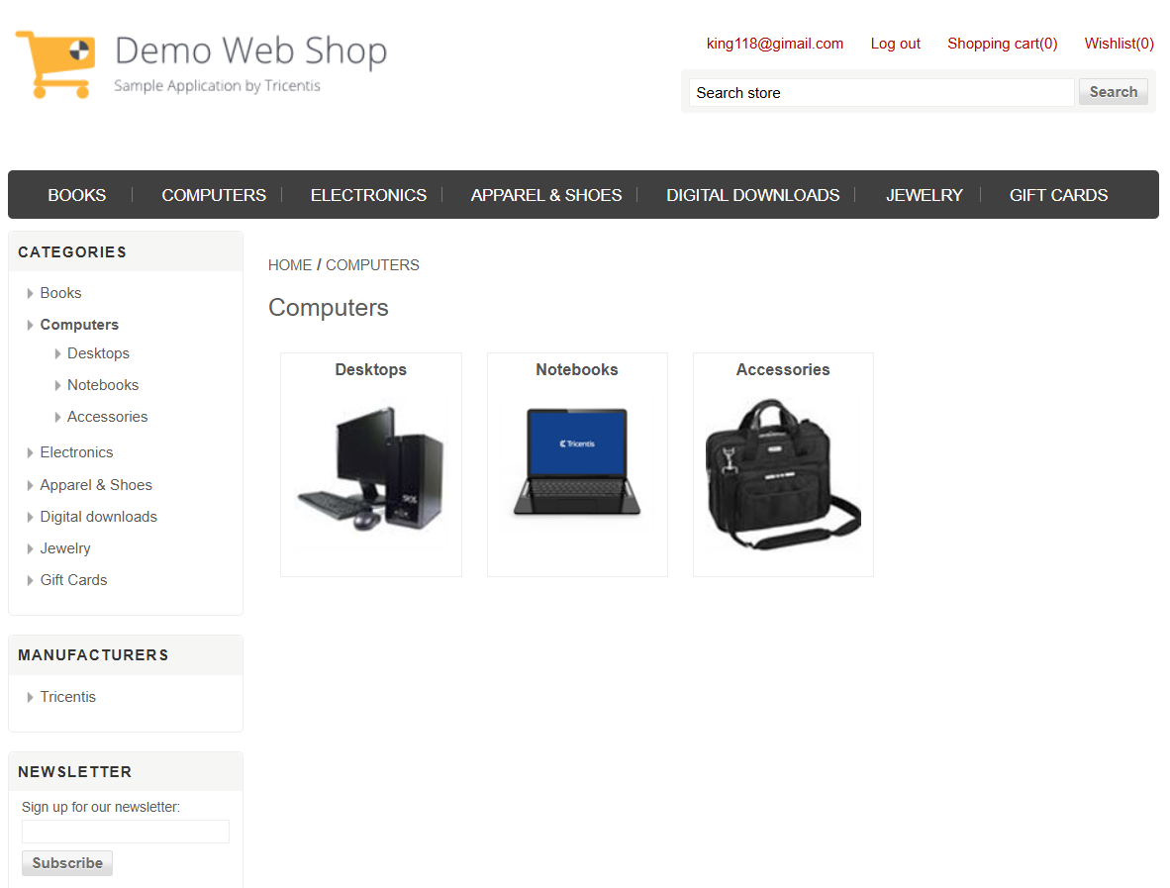

● Scenario ID: 3b
Scenario: buy something
Test Steps:
1. tap to add cart 2. buy pc
Screen short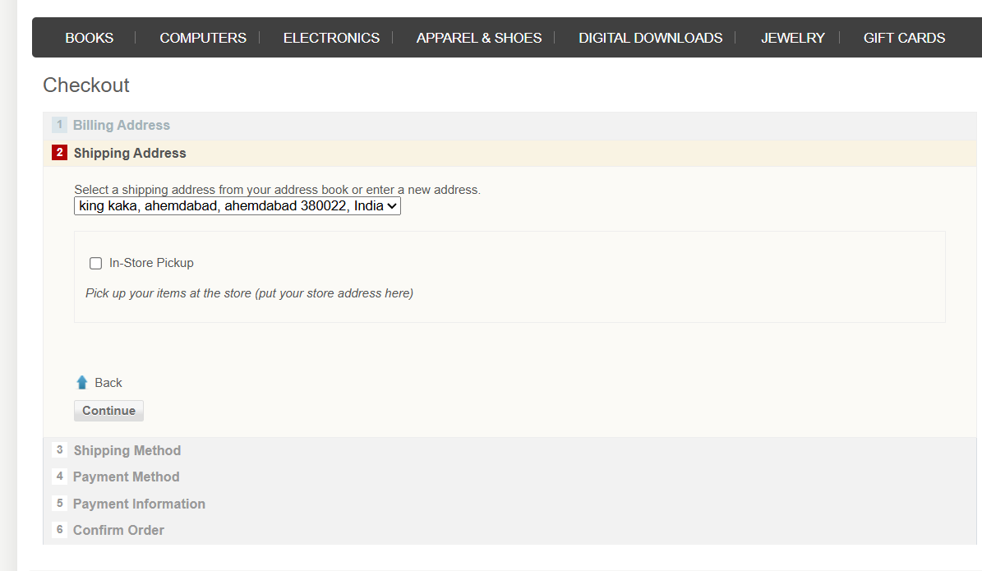
● Scenario ID: 4a
Scenario: log out
Test Steps:
1. tap to logout
Screen short